**SECTION A**

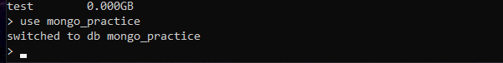

Database creation



Collection creation

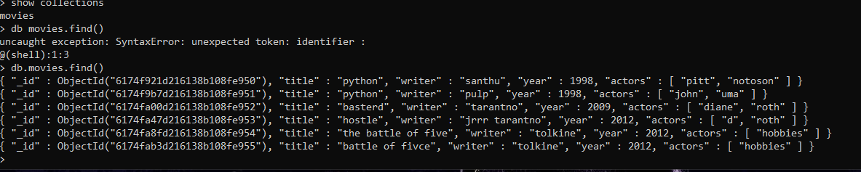

Documents creation

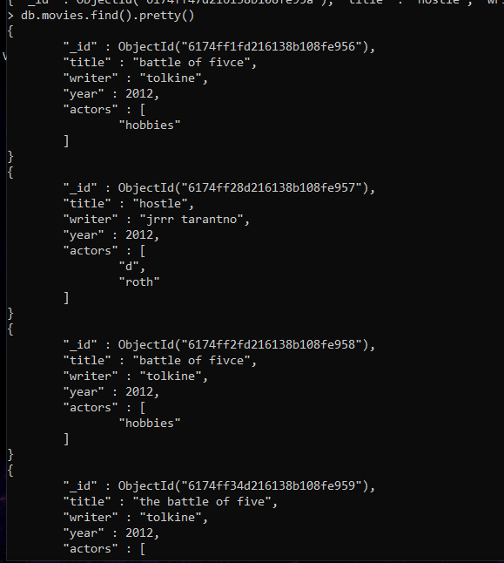

Finding one document

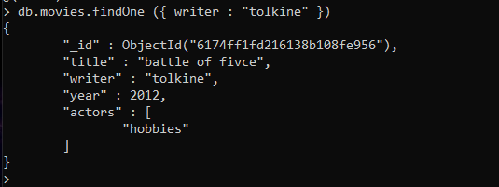

Found a coloums tolkine

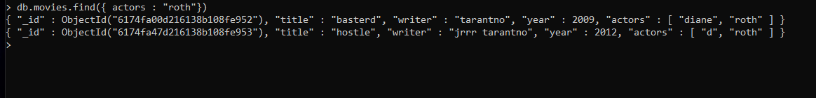

Found actors



Foound hostle



Found year query



Data leser than the year 2000

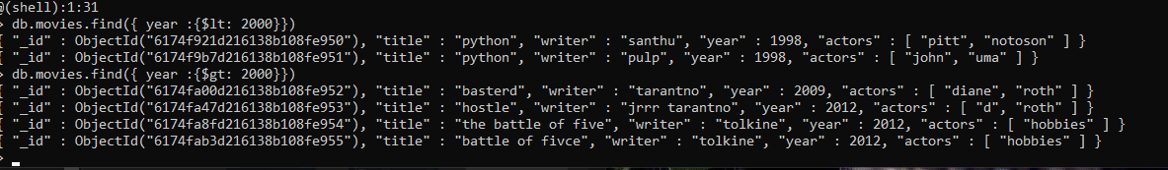

Greater than the year 2000

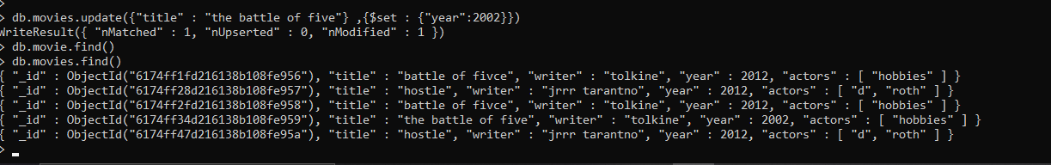

Updated information

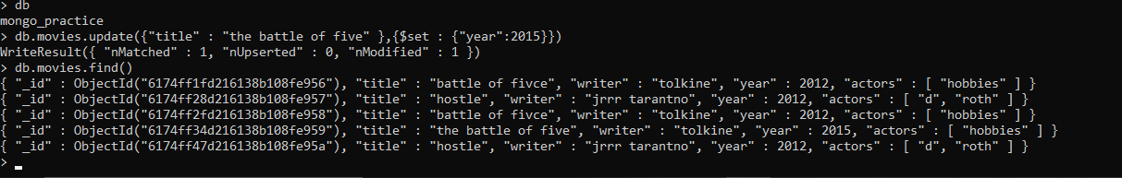

Updated information about year

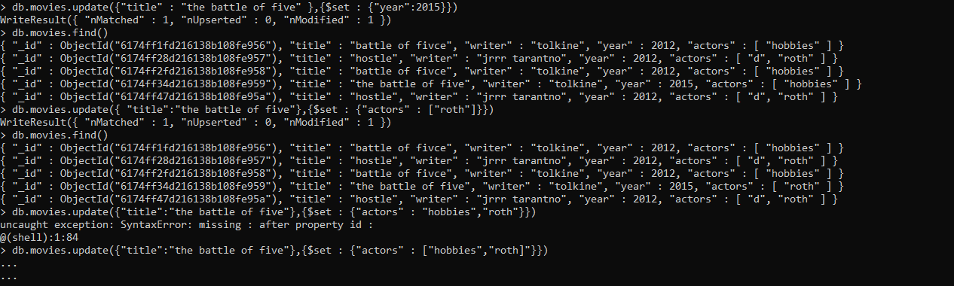

Added information

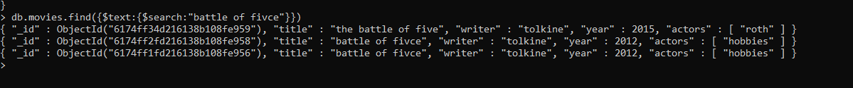

Searching a text through textIndexing

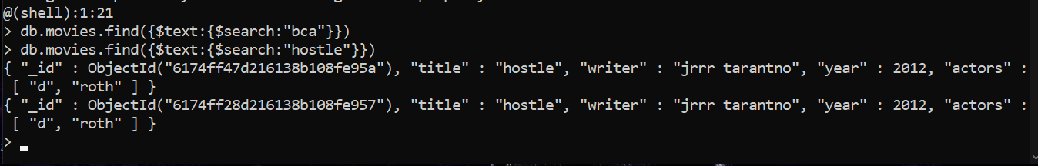

Searching on title by textIndexing

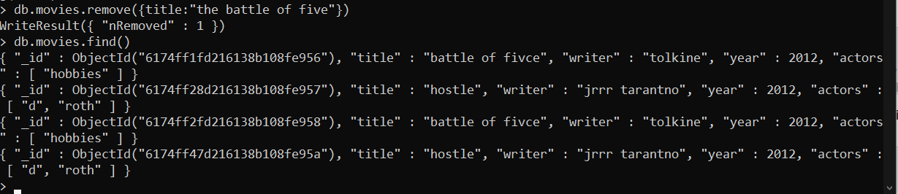

Removing collection

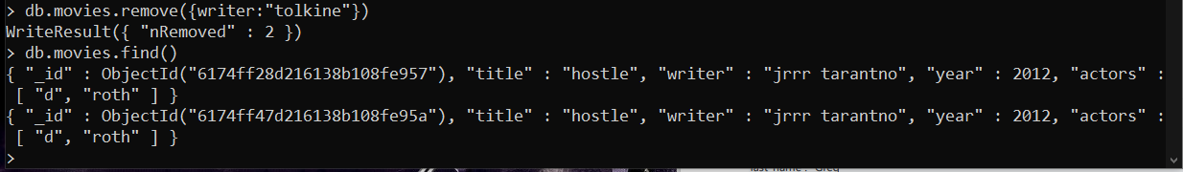

Removed writer tolkine

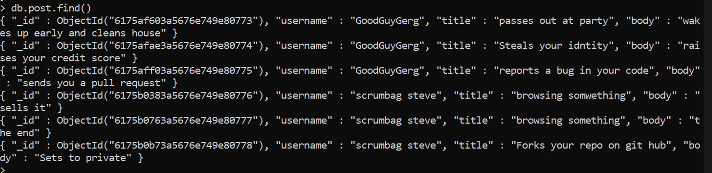

Find all the posts



Find all the users

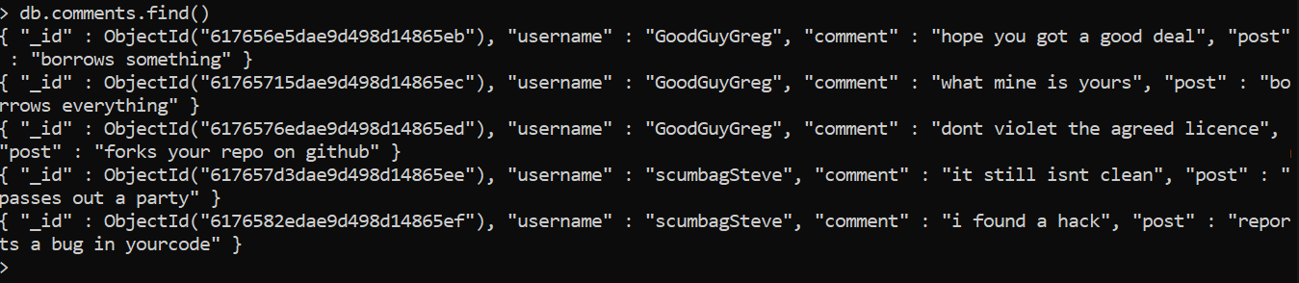

Find all comments

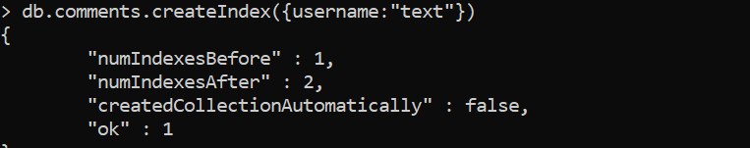

Creating textindex on comments

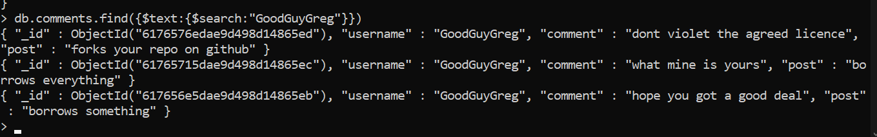

Goodguy search for indexing

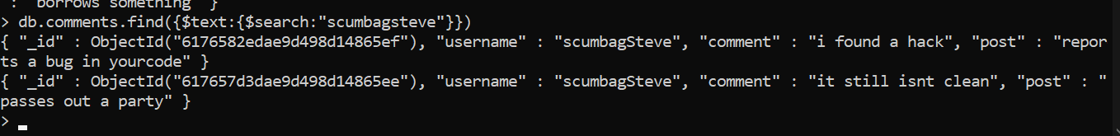

Scumbugsteve search by text Indexing

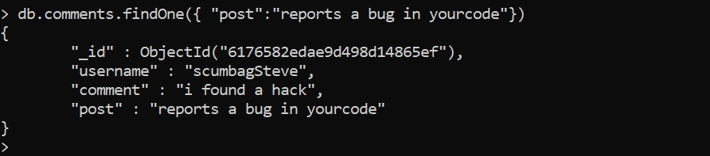

Find a post with”reports a bug in your code”